DATE: June 15, 2018
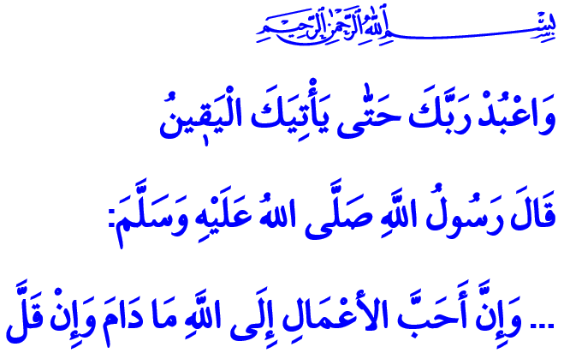
SPENDING A LIFE WITH THE AWARENESS OF SERVITUDE TO ALLAH
Jum’uah Mubarak Honorable Brothers and Sisters!
One day, Our Prophet (s.a.w.) was asked, “Which act is the most precious before Allah?” The beloved Messenger replied, “The acts most precious before Allah are those which are done continuously, even if they are small.”
This answer indicated that worship and servitude, goodness and benevolence need a balance and an order. With this answer, the Prophet of Mercy advised us to observe simplicity and continuity in worshiping Our Lord as a sign of our faith. In order to keep our awareness for servitude for a lifetime, our ties of affection with Allah Almighty needed to be regularly fed with our prayers and deeds.
Estimable Brothers and Sisters!
We had an indescribable joy with the arrival of the Holy Ramadan, and we had welcomed it with great enthusiasm. We had experienced the spiritual peace of reaching the season of fasting, iftar, suhur, tarawih, and muqabala. Today, we are bidding farewell to the schooling of Ramadan which trained us, dignified us, warned us against the desires of the nafs, and encouraged us for good deeds. We are ending the month of forgiveness which equipped our souls and our tables with its riches and generosity for the whole month. May Our Lord make us of His servants who duly observed Ramadan and are honored by Ramadan. May He allow us to reach many blessed months and eids.
Honorable Believers!
During the Holy Ramadan, we stood up for salat day and night as instructed by this verse from the Qur’an, “Certainly will the believers have succeeded. They who are during their prayer humbly submissive.” We prostrated ourselves, knowing our weakness. We questioned ourselves, we repented and we prayed. We ran for tarawih with an extra ardor, relieving not only our bodies, but also our hearts. We realized again the value of health, time, youth, a morsel of food, and a sip of water. We felt the bliss of pleasing our brothers and sisters with zakat, fitr and sadaqas.
We once again remembered the great responsibility to extend a hand to the relatives, the orphans, the refugees, the poor and the forlorn. We grasped the wisdom in Our Prophet’s (s.a.w) saying, “O Aisha, what you have distributed is our, not what you left.” when an animal had been sacrificed and its meat had been allotted and distributed.

Brothers and Sisters!

In the month of forgiveness, we prayed for forgiveness and mercy from Our Lord with the good tidings of “Indeed, He is ever Accepting of repentance.” We tried to be purified from our sins with our gratitude and prayers during iftar, and with our repentance and supplication.

Following the divine order of “And hold firmly to the rope of Allah (the Qur’an) all together and do not become divided.” we refrained from all kinds of disunity and discord in this season of mercy. We became one and we stood for unity, forgetting all our differences. We strengthened our brotherhood with the iftar tables we attended together, tarawih prayers we did shoulder to shoulder, and the charity activities which found abundance by sharing.
Dear Brothers and Sisters!
Now, it is time to look after the beauties acquired from Ramadan and spread them all over the year, even the entire lifespan. It is time to set Ramadan as a starting point which disciplined our lives, refreshed our awareness of servitude, and conduced that we deploy all our material and spiritual possibilities for the goodness of humanity. It is time to follow the Holy Qur’an, which reminds us that our responsibility will continue until our last breath as enjoined in this verse, “And worship your Lord until there comes to you the certainty (death).”
Estimable Muslims!
Let us make the peace and awareness of Ramadan rule over our lives. Let us maintain our ties with our Holy Book–the Qur’an. Let us continue frequenting the mosques with our families just as we did in Ramadan, and do not leave the masjids in gloom. Let us stand by everybody who needs our love, compassion, attention, and support. Let us earnestly avoid words and behaviors which undermine our unity and solidarity and weaken us by playing us against each other. May Allah ordain all of us to protect the legacy of Ramadan, and to have good morals and to be constant in worshipping.

Muslim, Salat al-Musafirin, 216.
Mu’minun, 23/1-2.
Tirmidhi, Sifat al-Qiyamah, 35.
Nasr, 110/3.
Al-i ‘Imran, 3/103.
Hijr, 15/99. General Directorate of Religious Services

